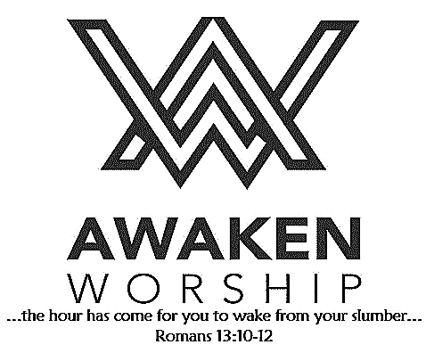

If you are visiting, thanks for being our

guest today. Please fill out the guest

info sheet in this bulletin. Take it to

the Welcome Desk after worship so we may introduce ourselves and give you a gift as our thanks to you for joining us today.

**On Wednesday, November 20, COOL Worship will be replaced by the OFFER GRATITUDE family event, as some of our children from WSUMC will be participating in the children’s choir. Parents, please join your kids at the Union Hall, 6:30 p.m. for this special family event.**

**Next Sunday, November 10**, between services (10:00-10:30 a.m.), anyone who is interested in membership at WSUMC is invited to join us in the fellowship hall as we discuss our vision, our mission and

what it means to be a member. Those who are already members are welcome to join in this informal discussion. Call the church office if you would like more information.

**2020 STEWARDSHIP CAMPAIGN**

Your church staff and leadership team are currently working

on the 2020 budget and will be providing ***Intention of Giving***

cards to everyone. Please prayerfully consider how you will

be able to financially support Wayne Street UMC’s mission of loving God, loving people and changing the world.

**HEAD TO TOE** isa project of a group of Memorial High School students who want to collect clothing for people in need in our communities. There are containers on the Mission Table in the fellowship hall for donations of hats, gloves, shirts, pants, shoes, socks and more. Extra-large (XL, XXL, etc.) are especially needed. See the lists on the containers for more information. Please - in clean, wearable condition. Thank you!

If you have not yet done so, grab an **Operation**

**Christmas Child shoebox** to fill! They are available in

the fellowship hall. Don’t want to fill a box but would like to contribute to this worthy project? Donations (marked OCC) may be dropped in the offering plate or sent to the church office by November 17. Your donation will be used to purchase items for boxes or to cover postage.

Wayne Street

United Methodist Church

Love God. Love People. Change the World.

130 N. Wayne St., Saint Marys, OH

419-394-3615 [waynestreetoffice@gmail.com](mailto:waynestreetoffice@gmail.com)

[**http://www.waynestreetumc.org**](http://www.waynestreetumc.org)

**Pastor Tim Benjamin**

***Church Office Hours:***

Monday 1:30 – 4:30 pm

Tuesday thru Thursday 8:30 am – 12 / 1:30 – 4:30 pm

***Closed Friday***

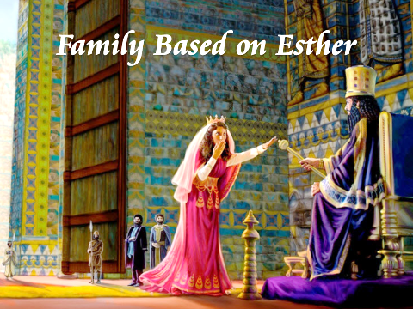

**November 3, 2019 10:45 a.m.**

**Pastor Tim Benjamin**

**(Worship Our Way!) *during AWAKEN***

*for children age 3 – 5th grade*

**Jessica Skinner, Director of Children’s Discipleship**

*Thanks for joining us as we:*

**Operation Christmas Child Video Clip**

**GATHER**

**CELEBRATE**

**PRAYER**

**LEARN**

**“Family Based on Esther”**

Esther 2:5-7

**RECEIVE AND REMEMBER**

**SERVE**



**Jesus Heals**



**Pastoral Care:** Call Pastor Tim at 419.394.3615 (choose ***option 2*** - pastoral care/emergency). If he is unable to answer, he will return your call as soon as possible.

**Prayer Concerns:** Family of Nick Doseck (father of Becky Jacobs), Family of Dick Brock, Tim Hullinger (cancer), Bob Schnarre, Carolyn Waterman

**Altar Flowers** are given by Tim and Jennie Barnes.

**FARMERS’ MEAL** and Country Store

this WEDNESDAY, NOVEMBER 6

Everyone is welcome! Bring your friends and family.

Bless someone who cannot attend – carry-out meals will be available.

Home-cooked meals served 4:30 – 6:30 p.m.

Country Store hours: 12:00 – 6:30 p.m.

**Accepting donations** of baked goods, homemade candies, noodles, etc. for the country store. Please deliver to the church during office hours (*use Wayne St. door*) Tuesday,

Nov. 5 or 6:00-7:30 pm (*main entrance*),

or after 10 am on Wednesday, Nov. 6.

Thank you!

*Sponsored by the United Methodist Women*

**LADIES’ LUNCH BUNCH**

**Maria Stein Shrine of the Holy Relics** will be the destination of our November outing. Mark your calendar for Tuesday, November 19. Cost will be $15 per person, which will include a meal and a tour. All women are welcome. **Sign-up sheets** are located at the information table in the fellowship hall.

**Tuesday, November 5**

6:30 pm – Celebrate Recovery

**Wednesday, November 6**

12:00 – 6:30 pm – UMW Country Store

4:30 – 6:30 pm – UMW Farmers’ Meal

6:00 pm – COOL Worship for children age 3 – 5th grade

6:00 pm – Youth meeting

7:00 pm – Chancel Choir Practice

**Thursday, November 7**

9:00 am – Women of the Cloth sewing group

7:00 pm – AWAKEN Band practice

**Friday, November 8**

Church office closed

**Hospitality Team: Sunday, November 10:**

***Kitchen Help*:** Carl & Linda Horn, Cheryl Koppelman,

Karen Bailey

***Clean-up:*** Jessen / Smith / Skelding

***Bakers:*** Faith Hoagland, Cheryl Koppelman, Valerie Cisco,

Carol Burnett, Carol Widney, Nicole Perin, Sandy Frey

**Liturgist for Sunday, November 10:** Candy Dicke

**Liturgist for Sunday, November 17:** James Schnelle

**MINISTERS: The Congregation**

**Pastor: Tim Benjamin** 419.394.3615, 740.262.7991

**Dirs., Student Discipleship: Phil / Leah Downs** 419.971.4321

**Dir., Children’s Discipleship: Jessica Skinner** 567.204.0312

**AWAKEN Worship Leader: Josh Barnes** 419.394.3615

**Office Manager: Diane Menchhofer** 419.394.3615

**Financial Controller: Angie Myers** 419-394-3615

**Choir Director & Organist: Darryl Smith** 419.953-2337

**Organist: Pam Wendel** 419.394.3615

**Nursery Coordinator: Kendra Syndram** 419.394.3615

**Custodian: Fred Hullinger** 419.394.3615

**Assistant Custodian:** **Gary Wibbeler** 419.394.3615

**Last Week:** Giving Toward Budget: $ 11,729

Attendance: 340

First Light

Worship Celebration

November 3, 2019 8:30 a.m.

**\*Gathering Song** “Through It All” **# 507**

“Lead Me, Lord” **# 473**

**Welcome and Announcements**

**Operation Christmas Child Video Clip**

**Prelude**

**Responsive Reading:** Psalm 23  **# 137**

**Gloria Patri # 70**

**\*Opening Hymn** “Guide Me, O Thou Great Jehovah” **# 127**

**Sharing the Journey**

**Pastoral Prayer**

**Anthem**  “How Beautiful” Larson

The Chancel Choir

**Scripture Reading:** Esther 2:5-7

**Message** “Family Based on Esther” Pastor Tim

**Holy Communion and Offering**

**\*Hymn of Response** “Here I Am, Lord” **# 593**

**\*Sending Prayer**

**Postlude**

*(*) Please stand if you are able.*

**Today’s Organist:** Pam Wendel

**Today’s Liturgist:** Jack Miller

This Week at Wayne Street



**Go**

**Share Your Faith!**

**Even though I walk through the darkest valley**

**I will fear no evil**

**for**

**you are with me.**

**Your rod and your staff they comfort me.**

Psalm 23:4

**Our STAFF at Wayne Street UMC**