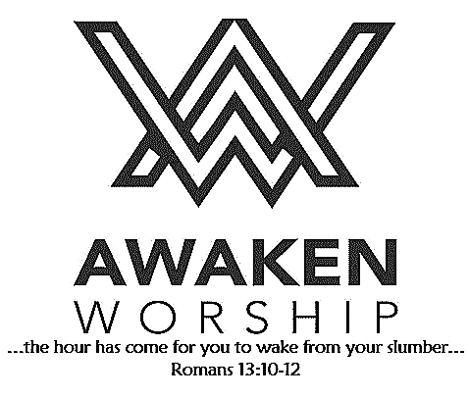

If you are visiting, thanks for being our

guest today. Please fill out the guest

info sheet in this bulletin. Take it to

the Welcome Desk after worship so we may introduce ourselves and give you a gift as our thanks to you for joining us today.

**2020 STEWARDSHIP CAMPAIGN**

Your church staff and leadership team are currently working

on the 2020 budget and are providing ***Intention of Giving***

cards to everyone. Please prayerfully consider how you will

financially support Wayne Street UMC’s mission of loving God, loving people and changing the world.

Thanks to all who are filling shoeboxes for Operation

Christmas Child. You are blessing children who may

be receiving their very first gift. Our goal is 500, but

how many more children could we bless if we each packed

just **ONE MORE** box? *One more child blessed with a gift, one more child learning about Jesus.*

**Filled boxes are to be returned to the church by Sunday, Nov. 17.**

**TODAY** between services (10:00-10:30 a.m.), anyone who is interested in membership at WSUMC is invited to join us in the fellowship hall as we discuss our

vision, our mission and what it means to be a member. Those who are members are welcome to join in this informal discussion.

A **MISSION TRIP TO GUATEMALA** is being planned for September 2020. Exact dates are undetermined at this time, but the trip will be scheduled for one week. Projects for our time there will depend on the abilities of those who wish to go. Approximate cost, which will include flight, hotels, transportation and most meals, will be $1100-1400 per person. The Mission Committee may be able to offer some financial assistance. Other costs travelers may incur include getting a passport, shots, travel insurance and discretionary spending. Must be 18 years old or older. Teens are welcome if they travel with a parent or legal guardian. More details will be shared as they become available.

For more information, contact Brad Goodwin (419-394-6601).

**Welcome!**

Wayne Street

United Methodist Church

Love God. Love People. Change the World.

130 N. Wayne St., Saint Marys, OH

419-394-3615 [waynestreetoffice@gmail.com](mailto:waynestreetoffice@gmail.com)

[**http://www.waynestreetumc.org**](http://www.waynestreetumc.org)

**Pastor Tim Benjamin**

***Church Office Hours:***

Monday 1:30 – 4:30 pm

Tuesday thru Thursday 8:30 am – 12 / 1:30 – 4:30 pm

***Closed Friday***

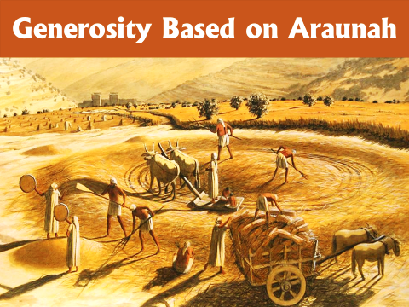

**November 10, 2019 10:45 a.m.**

**Pastor Tim Benjamin**

**(Worship Our Way!) *during AWAKEN***

*for children age 3 – 5th grade*

**Jessica Skinner, Director of Children’s Discipleship**

*Thanks for joining us as we:*

**OPERATION CHRISTMAS CHILD – One More!**

**GATHER**

**CELEBRATE**

**PRAYER**

**LEARN**

**“Generosity Based on Araunah”**

1 Chronicles 21:18-26

**GIVE**

**SERVE**





**Jesus Heals**

**Pastoral Care:** Call Pastor Tim at 419.394.3615 (choose ***option 2*** - pastoral care/emergency). If he is unable to answer, he will return your call as soon as possible.

**Prayer Concerns:** Tim Hullinger (cancer), Bob Schnarre, Carolyn Waterman, Aaron Adams

**Altar Flowers** are given by Jodi Hertenstein in memory of her parents.

**LADIES’ LUNCH BUNCH**

**Maria Stein Shrine of the Holy Relics** will be the destination of our November outing. Mark your calendar for Tuesday, November 19. Cost will be $15 per person, which will include a meal and a tour. All women are welcome. **Sign-up sheets** are located at the information table in the fellowship hall.

**HEAD TO TOE** isa project of a group of Memorial High School students who want to collect clothing for people in need in our communities. There are containers on the Mission Table in the fellowship hall for donations of hats, gloves, shirts, pants, shoes, socks and more. Extra-large (XL, XXL, etc.) are especially needed. See the lists on the containers for more information. Please - in clean, wearable condition. Thank you!

**ADVENT BREAKFAST**

Women of Wayne Street UMC are cordially invited to Zion Lutheran Church’s annual Advent Breakfast. It will be held at Zion (in their auditorium) on Tuesday, December 3, 9:30 a.m. The program is “The Chrismon Christmas Tree.” Please make reservations by calling the church office at 419-394-3115, by Wednesday, November 27. (An elevator is available for your convenience.)

**Haiti Update:** In October, the Mission Team challenged the congregation to match the team’s donation of $2,000 to HIS Home for Children. WOW! Your generous response well exceeded that match! $5,041 was received; therefore, a total of **$7,041** was provided for HIS Home. Thank you!

**The Lord is near to all who call on Him.**

Psalm 145:18

**Today, November 10**

Between Services – New Member Orientation

**Tuesday, November 12**

6:30 pm – Celebrate Recovery

7:15 pm – Sonshine Circle

**Wednesday, November 13**

6:00 pm – COOL Worship for children age 3 – 5th grade

6:00 pm – Youth meeting

7:00 pm – Chancel Choir Practice

**Thursday, November 14**

9:00 am – Women of the Cloth sewing group

7:00 pm – AWAKEN Band practice

**Friday, November 15**

Church office closed

**Hospitality Team: Sunday, November 17:**

***Kitchen Help*:** Brad and Jeannine Goodwin

***Clean-up:*** Goodwin / Keller

***Bakers:*** Mindy Wirwille, Jennifer Vondrell, Marcy Keith,

Julie Jacobs, April Johns, Paula Yahl

**Liturgist for Sunday, November 17:** James Schnelle

**Liturgist for Sunday, November 24:** Kraig Noble

**MINISTERS: The Congregation**

**Pastor: Tim Benjamin** 419.394.3615, 740.262.7991

**Dirs., Student Discipleship: Phil / Leah Downs** 419.971.4321

**Dir., Children’s Discipleship: Jessica Skinner** 567.204.0312

**AWAKEN Worship Leader: Josh Barnes** 419.394.3615

**Office Manager: Diane Menchhofer** 419.394.3615

**Financial Controller: Angie Myers** 419-394-3615

**Choir Director & Organist: Darryl Smith** 419.953-2337

**Organist: Pam Wendel** 419.394.3615

**Nursery Coordinator: Kendra Syndram** 419.394.3615

**Custodian: Fred Hullinger** 419.394.3615

**Assistant Custodian:** **Gary Wibbeler** 419.394.3615

**Last Week:** Giving Toward Budget: $ 11,391

Attendance: 355

First Light Worship Celebration

November 10, 2019 8:30 a.m.

**\*Gathering Song** “Great Is the Lord”

**Welcome and Announcements**

**Operation Christmas Child: ONE MORE!**

**Prelude** “Morning” Grieg

**Responsive Reading:** Psalm 145:1-5, 17-21  **# 857**

**Gloria Patri # 70**

**\*Opening Hymn** “God Is Here” **# 660**

**Sharing the Journey**

**Pastoral Prayer**

**Offertory/Offering** “Lord, I Lift Your Name on High” Wagner

**\*Doxology**

**\*Offertory Prayer**

**Anthem** “Take It to the Lord in Prayer” Raney

The Chancel Choir

**Scripture Reading:** 1 Chronicles 21:18-26

**Message** “Generosity Based on Araunah” Pastor Tim

**\*Hymn of Response** “Sent Forth by God’s Blessing” **# 664**

**\*Sending Prayer**

**Postlude** “Rondeau” Mouret

*(*) Please stand if you are able.*

**Today’s Organist:**  Darryl Smith **Today’s Liturgist:** James Schnelle

This Week at Wayne Street

**Our STAFF at Wayne Street UMC**