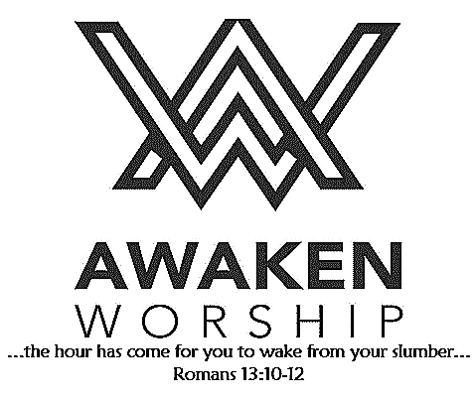

If you are visiting, thanks for being our guest today. Please fill out the guest info sheet in this bulletin. Take it to the

Welcome Desk after worship so we may introduce ourselves and give you a gift as our thanks to you for joining us today.

The annual WARM WINTER COAT DRIVE, sponsored by Agape Ministries, is being held through October 21. Donations of clean, gently used or new winter coats of all sizes may be brought to the church (barrels available in the fellowship hall).

**GOOD NEWS, GREAT JOY!** Would you like to

help bring the good news of Jesus and great joy to a child this year? Volunteers are needed on **Sunday, October 13 and Sunday, October 20** between worship services (from 9:30-10:45 a.m.) to assist with assembling our Operation Christmas Child shoeboxes. We will also be placing encouraging words and/or scripture inside each box. Please join us in the fellowship hall; your help will be appreciated.

**OCC shoeboxes** will be handed out on Sunday, Oct. 27, and will be due back by November 17. A list of gift ideas to pack can be found on the Info Table, the Welcome Desk and in the church office. Watch for more information!

Tuesday, October 15

Lunch at

**600 Downtown Restaurant**,

Leaving the church at 11 a.m., Bellefontaine

Lunch at 12 noon, followed by

shopping in downtown Bellefontaine. All women are welcome.

Sign up to join us!

Wayne Street

United Methodist Church

Love God. Love People. Change the World.

130 N. Wayne St., Saint Marys, OH

419-394-3615 [waynestreetoffice@gmail.com](mailto:waynestreetoffice@gmail.com)

[**http://www.waynestreetumc.org**](http://www.waynestreetumc.org)

**Pastor Tim Benjamin**

***Church Office Hours:***

Monday 1:30 – 4:30 pm

Tuesday thru Thursday 8:30 am – 12 / 1:30 – 4:30 pm

***Closed Friday***







**October 6, 2019 10:45 a.m.**

**Pastor Tim Benjamin**

**(Worship Our Way!) *during AWAKEN***

*for children age 3 – 5th grade*

**Jessica Skinner, Director of Children’s Discipleship**

*Thanks for joining us as we:*

**GATHER**

**CELEBRATE**

**PRAYER**

**LEARN**

**“Love Based On Naomi”**

Ruth 1:1-18

**RECEIVE AND REMEMBER**

**SERVE**







**Jesus Heals**



**Pastoral Care:** Call Pastor Tim at 419.394.3615 (choose ***option 2*** - pastoral care/ emergency). If he is unable to answer, he will return your call as soon as possible.

**Prayer Concerns:** Mary Musilek (mother of Dave Burkholder) – surgery/pain (Cards may be sent to Mary at 100 Red Oak Dr., Cridersville, OH 45806.)

**Altar Flowers** are given in memory of Kenneth Jacobs by his family.

***It’s not too late!*  Please join one of**

**the many opportunities to take part in**

**a small group during our 40-day**

**church-wide spiritual growth**

**effort to focus on community.**

**Farmers’ Meal and Country Store**

**Wednesday, November 6**

Everyone is welcome to enjoy this annual event sponsored by our United Methodist Women. The country store will have homemade goodies, such as noodles, cookies, pies, and more, open from 12 – 6:30 p.m. The meal, offering ham loaf, chicken, side dishes, desserts and drinks, will be served from 4:30 – 6:30 p.m. Invite your family and friends! All net proceeds are used to support women and children in need.

**Tuesday, October 8**

6:30 pm – Celebrate Recovery

**Wednesday, October 9**

6:00 pm – COOL Worship for ALL children age 3 - 5th grade

6:00 pm – Youth meeting

7:00 pm – Chancel Choir Practice

**Thursday, October 10**

9:00 am – Women of the Cloth sewing group

7:00 pm – AWAKEN Band practice

**Friday, October 11**

Church office closed

**Hospitality Team: Sunday, October 13:**

***Kitchen Help*:** Linda & Carl Horn, Cheryl Koppelman,

Karen Bailey

***Clean-up:*** Jessen, Smith and Skelding

***Bakers:*** Nancy Painter, Mindy Wirwille, Rita Cassel,

Katelyn Freewalt, Rose Klenke

**Liturgist for Sunday, October 13:** Rita Cassel

**Liturgist for Sunday, October 20:** Debbie Knox

**MINISTERS: The Congregation**

**Pastor: Tim Benjamin** 419.394.3615, 740.262.7991

**Dirs., Student Discipleship: Phil / Leah Downs** 419.971.4321

**Dir., Children’s Discipleship: Jessica Skinner** 567.204.0312

**AWAKEN Worship Leader: Josh Barnes** 419.394.3615

**Office Manager: Diane Menchhofer** 419.394.3615

**Financial Controller: Angie Myers** 419-394-3615

**Choir Director & Organist: Darryl Smith** 419.953-2337

**Organist: Pam Wendel** 419.394.3615

**Nursery Coordinator: Kendra Syndram** 419.394.3615

**Custodian: Fred Hullinger** 419.394.3615

**Assistant Custodian:** **Gary Wibbeler** 419.394.3615

**Last Week:** Giving Toward Budget: $11,361

Attendance: 325

9-22-19 Giving Toward Budget: $8,296

First Light

Worship Celebration

October 6, 2019 8:30 a.m.

**\*Gathering Song** “This Little Light of Mine” **# 585**

**Welcome and Announcements**

**Prelude**

**Responsive Reading:** Psalm 146 **# 858**

**Gloria Patri # 70**

**\*Opening Hymn** “O For a Thousand Tongues to Sing” **# 57**

**Sharing the Journey**

**Pastoral Prayer**

**Anthem**  “Song of Ruth” Eilers

The Chancel Choir

**Scripture Reading:** Ruth 1:1-18

**Message** “Love Based on Naomi” Pastor Tim

**Holy Communion and Offering**

**\*Hymn of Response** Take Up Thy Cross” **# 415**

**\*Sending Prayer**

**Postlude**

*(*) Please stand if you are able.*

**Today’s Organist:** Pam Wendel

**Today’s Liturgist:** Dennis Chiles

This Week at Wayne Street





Sign up in the fellowship hall!

Groups start this week.

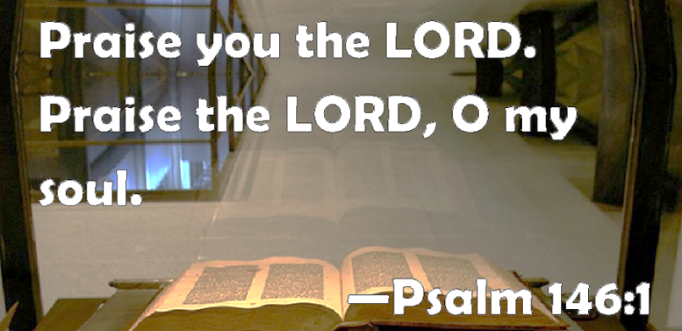

**Our STAFF at Wayne Street UMC**

Go in

Peace.

Serve the Lord.