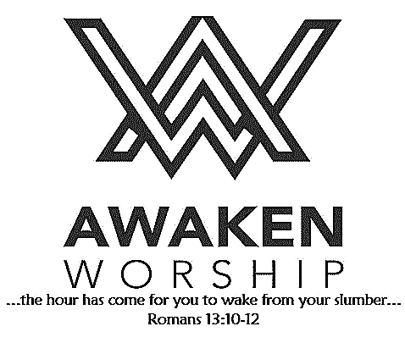

If you are visiting, thanks for being our

guest today. Please fill out the guest

info sheet in this bulletin. Take it to

the Welcome Desk after worship so we may introduce ourselves and give you a gift as our thanks to you for joining us today.

On **Sunday, November 10**, between services (10:00-10:30 a.m.), anyone who is interested in membership at WSUMC is invited to join us in the fellowship hall as we discuss our vision, our mission and

what it means to be a member. Those who are already members are welcome to join in this informal discussion. Call the church office if you would like more information.

**Thank you** for your support of the **Gideons**’ work and for allowing me time to share about this ministry. I also enjoyed the Sunday School Bible study. Truly the Holy Spirit is working in your church.

**Operation Christmas Child Shoeboxes**

are being distributed today! Please pick up a box

– or two or three! – to fill with gifts for children in

need around the world. If you prefer, you may donate items for boxes or money to help with shipping costs or to purchase items for someone else to fill boxes. Our goal is 500 filled boxes this year. Join us in sharing the love of Christ.

**Maria Stein Shrine of the Holy Relics** will be the destination of our November LADIES’ LUNCH BUNCH. Mark your calendar for Tuesday, November 19. Cost will be $15 per person, which will include a meal and a tour. All women are welcome. Sign-up will begin in November.

**OFFER GRATITUDE** Community Thanksgiving event

Wednesday, November 20, 6:30 – 7:30 p.m., SM Union Hall

**Giving Thanks** Community Meal,

11:00 a.m. – 2:00 p.m.

Thanksgiving Day, November 28,

St. Marys Memorial High School

Wayne Street

United Methodist Church

Love God. Love People. Change the World.

130 N. Wayne St., Saint Marys, OH

419-394-3615 [waynestreetoffice@gmail.com](mailto:waynestreetoffice@gmail.com)

[**http://www.waynestreetumc.org**](http://www.waynestreetumc.org)

**Pastor Tim Benjamin**

***Church Office Hours:***

Monday 1:30 – 4:30 pm

Tuesday thru Thursday 8:30 am – 12 / 1:30 – 4:30 pm

***Closed Friday***



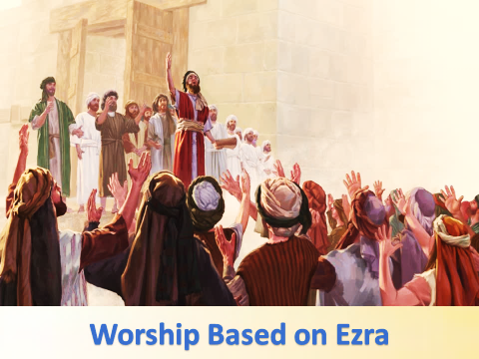

**October 27, 2019 10:45 a.m.**

**Pastor Tim Benjamin**

**(Worship Our Way!) *during AWAKEN***

*for children age 3 – 5th grade*

**Jessica Skinner, Director of Children’s Discipleship**

*Thanks for joining us as we:*

**GATHER**

**Mission Moment: OCC Shoeboxes**

Terry and Marty Frahm

**CELEBRATE**

**PRAYER**

**LEARN**

**“Worship Based on Ezra”**

Nehemiah 8:1-13

**GIVE**

**SERVE**



Mike Jackson

**Jesus Heals**

**Pastoral Care:** Call Pastor Tim at 419.394.3615 (choose ***option 2*** - pastoral care/ emergency). If he is unable to answer, he will return your call as soon as possible.

**Prayer Concerns:** Children and staff at HIS Home in Haiti, Bob Schnarre, Carolyn Waterman

**Altar Flowers** are given by Bob and Jane Schnarre in honor of their 67th wedding anniversary.

**FARMERS’ MEAL** – WEDNESDAY, NOVEMBER 6

**VOLUNTEERS (men and women) NEEDED** for 2-hour shifts:

to help prepare the meal,

serve as cashier, serve the meal,

assist with drinks and desserts,

bus tables and wash dishes, assist with seating guests,

staff the country store area, clean up after the meal,

or help wherever needed.

**Also accepting donations** of baked goods, homemade candies, noodles, etc. for the country store.

Please deliver to the church during office hours

Tuesday, Nov. 5 or by noon on Wednesday, Nov. 6.

Sign up in the fellowship hall or use the communication sheet in your bulletin if you are able to assist with this event.

Thank you!

**HAITI Support:** Donations to help the children at HIS Home continue to be collected today. Thanks to all who have given thus far to help with expenses at the orphanage.

**Collecting HATS for Agape through Nov. 1**

Hats can be donated at Agape or the high school; they will be sanitized and given away to those in need. Ball caps, winter hats, any kind of ***useful hat***, in good condition, will be accepted.

**Tuesday, October 29**

6:30 pm – Celebrate Recovery

**Wednesday, October 30**

6:00 pm – COOL Worship for children age 3 - 5th grade

6:00 pm – Youth meeting

7:00 pm – Chancel Choir Practice

**Thursday, October 31**

9:00 am – Women of the Cloth sewing group

6:00 pm – Trunk or Treat in church parking lot

7:00 pm – AWAKEN Band practice

**Friday, November 1**

Church office closed

**Hospitality Team: Sunday, November 3:**

***Kitchen Help*:** Tiffany Davis, Dixie Durkee

***Clean-up:*** Dicke / Lynch

***Bakers:*** Dixie Durkee / Choir

**Liturgist for Sunday, November 3:** Jack Miller

**Liturgist for Sunday, November 10:** Candy Dicke

**Communion Teams for November 3:**

**First Light:** Roberta Yingling

**AWAKEN:** Jennie and Sydney Barnes

**MINISTERS: The Congregation**

**Pastor: Tim Benjamin** 419.394.3615, 740.262.7991

**Dirs., Student Discipleship: Phil / Leah Downs** 419.971.4321

**Dir., Children’s Discipleship: Jessica Skinner** 567.204.0312

**AWAKEN Worship Leader: Josh Barnes** 419.394.3615

**Office Manager: Diane Menchhofer** 419.394.3615

**Financial Controller: Angie Myers** 419-394-3615

**Choir Director & Organist: Darryl Smith** 419.953-2337

**Organist: Pam Wendel** 419.394.3615

**Nursery Coordinator: Kendra Syndram** 419.394.3615

**Custodian: Fred Hullinger** 419.394.3615

**Assistant Custodian:** **Gary Wibbeler** 419.394.3615

**Last Week:** Giving Toward Budget: $ 8,360

Attendance: 281

Building Fund Balance: $ 18,558.07

First Light Worship Celebration

October 27, 2019 8:30 a.m.

**\*Gathering Song** “The Joy of the Lord”

**Welcome and Announcements**

**Mission Moment: OCC Shoeboxes** Terry and Marty Frahm

**Prelude** “Ein’ Feste Burg” Luther

**Holy Baptism: Rhett Christian Cain**

Son of Luke and Kaleigh Cain

**Responsive Reading:** Psalm 19:7-14 **# 751**

**Gloria Patri # 70**

**\*Opening Hymn** “A Mighty Fortress is Our God” **# 110**

**Sharing the Journey – Roll of Remembrance**

**Pastoral Prayer**

**Offering / Offertory** “Ashokan Farewell” Ungar

**\*Doxology**

**\*Offertory Prayer**

**Anthem**  “Shine on Us” Smith / Raney

The Chancel Choir

**Scripture Reading:** Nehemiah 8:1-13

**Message** “Worship Based on Ezra” Pastor Tim

**\*Hymn of Response** “Stand Up and Bless the Lord” **# 662**

**\*Sending Prayer**

**Postlude** “Diadem” Bonighton

*(*) Please stand if you are able.*

**Today’s Organist:** Darryl Smith **Today’s Liturgist:** Trena Chiles

This Week at Wayne Street

Meal served 4:30-6:30 p.m.

Country Store

12 – 6:30 p.m.



**Now is a great time to change the**

**batteries in your smoke detectors.**

It’s time to FALL back! **Turn your clocks back one hour on Saturday, November 2.**

**Our STAFF at Wayne Street UMC**