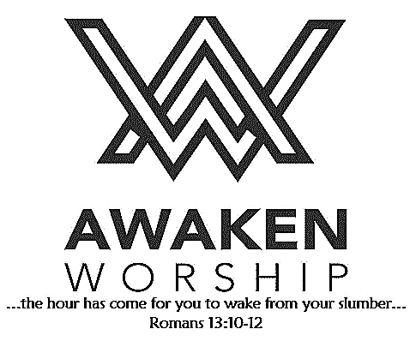

If you are visiting, thanks for being our guest today. Please fill out the guest info sheet in this bulletin. Take it to the

Welcome Desk after worship so we may introduce ourselves and give you a gift as our thanks to you for joining us today.

**Thank You**for making Festival of Sharing a success this year. These gifts are a huge blessing to families when they need them the most, especially when they are struggling after a disaster strikes. I am thankful that we can be prepared to help our neighbors near and far.

Matthew Stevens, Festival of Sharing Comm.

**“OFFER GRATITUDE”**

**Community Thanksgiving Event**

Wednesday, November 20, 6:30-7:30 p.m.,

at the St. Marys Union Hall

*sponsored by the Ministerial Association*

Bring your family and enjoy seasonal music, beverages and snacks provided as you fellowship with others.

A professional auctioneer will sell off donated baked goods, with the funds raised to benefit those in need in our area.

If you would like to donate baked goods, have them at the Union Hall by 6:00 p.m. that evening.

Blood Drive in the fellowship hall

Monday, Oct. 21, 12 noon – 6 p.m.

Grand Lake Symphony Orchestra Fall Concert will be presented today at 3:00 p.m. at St. John Lutheran Church, 1100 N. Main St., Celina. The public is invited.

Prayer

is the best wireless connection

to GOD.

Wayne Street

United Methodist Church

Love God. Love People. Change the World.

130 N. Wayne St., Saint Marys, OH

419-394-3615 [waynestreetoffice@gmail.com](mailto:waynestreetoffice@gmail.com)

[**http://www.waynestreetumc.org**](http://www.waynestreetumc.org)

**Pastor Tim Benjamin**

***Church Office Hours:***

Monday 1:30 – 4:30 pm

Tuesday thru Thursday 8:30 am – 12 / 1:30 – 4:30 pm

***Closed Friday***



Saturday, Nov. 2:

Time change - turn your clock back!

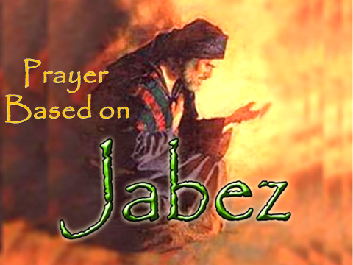



**October 20, 2019 10:45 a.m.**

**Pastor Tim Benjamin**

**(Worship Our Way!) *during AWAKEN***

*for children age 3 – 5th grade*

**Jessica Skinner, Director of Children’s Discipleship**

*Thanks for joining us as we:*

**GATHER**

**CELEBRATE**

**PRAYER**

**LEARN**

**“Prayer Based on Jabez”**

1 Chronicles 4:9-10

**GIVE**

**SERVE**





**Jesus Heals**



**Pastoral Care:** Call Pastor Tim at 419.394.3615 (choose ***option 2*** - pastoral care/ emergency). If he is unable to answer, he will return your call as soon as possible.

**Prayer Concerns:** Dick Brock, John Harlett,Children and staff at HIS Home in Haiti

**Altar Flowers** are given by Bill and Patsy Schwendeman in honor of their 50th wedding anniversary.

**Additional Altar Flowers**

* are given in honor of the 65th wedding anniversary

of Bob and Myrna Wolfe by son Tim and Laura Wolfe, grandchildren and great-grandchildren.

* are given in honor of the 94th birthday of Dorothy Dennings

**The Farmers’ Meal** , sponsored by the United Methodist Women, is scheduled for Wednesday, November 6. **Volunteers (men and women) are needed to**:

* help with the country store and / or the meal (preparing, serving, clean-up, etc.)
* provide salads, pies, etc. for the meal
* provide homemade baked goods, candies, etc. for the country store

Sign-up forms are in the fellowship hall. Please check them out and see where or how you might be able to serve.

***NOTE:*** *The Sonshine Circle will meet on* ***Tuesday, November 12****, instead of November 5, due to the Farmers’ Meal on November 6. All women are welcome to attend the meeting, which will be held at the home of Jackie Hullinger. For more information, contact the church office.*

**Thanks to everyone who helped assemble the OCC shoeboxes** last Sunday! The boxes will be handed out next Sunday, October 27, and will be due back by November 17.

A list of gift ideas to pack can be found on the Info Table, the Welcome Desk and in the church office.

**Our goal for 2019 is 500 packed shoeboxes!**

Prefer to donate toward the project?

A donation of items for boxes or a cash donation to

purchase gift items would be welcome!

**Monday, October 21**

   12 noon – 6:00 pm – Red Cross Blood Drive

**Tuesday, October 22**

   6:30 pm – Celebrate Recovery

   7:00 pm – W.I.L.L. Emmaus Share Group

**Wednesday, October 23**

   6:00 pm – COOL Worship for children age 3 – 5th grade

   6:00 pm – Youth meeting

   7:00 pm – Chancel Choir Practice

**Thursday, October 24**

   9:00 am – Women of the Cloth sewing group

   7:00 pm – AWAKEN Band practice

**Friday, October 25**

   Church office closed

**Hospitality Team: Sunday, October 27:**

***Kitchen Help*:** Kendra Seewer, Cheryl Miller, Tim Kohlhorst

***Clean-up:*** Sutton / Robinson / Poff / Shannon

***Bakers:*** Ellen Adams, Kris Jacobs, Christi Yahl,

Linda Freewalt, Becky Jacobs

**Liturgist for Sunday, October 27:** Trena Chiles

**Liturgist for Sunday, November 3:** Jack Miller

**MINISTERS: The Congregation**

**Pastor: Tim Benjamin** 419.394.3615, 740.262.7991

**Dirs., Student Discipleship: Phil / Leah Downs** 419.971.4321

**Dir., Children’s Discipleship: Jessica Skinner** 567.204.0312

**AWAKEN Worship Leader: Josh Barnes** 419.394.3615

**Office Manager: Diane Menchhofer** 419.394.3615

**Financial Controller: Angie Myers** 419-394-3615

**Choir Director & Organist: Darryl Smith** 419.953-2337

**Organist: Pam Wendel** 419.394.3615

**Nursery Coordinator: Kendra Syndram** 419.394.3615

**Custodian: Fred Hullinger** 419.394.3615

**Assistant Custodian:** **Gary Wibbeler** 419.394.3615

**Last Week:** Giving Toward Budget: $7,902

Attendance: 314

First Light Worship Celebration

October 20, 2019 8:30 a.m.

**\*Gathering Song** “On Eagle’s Wings” **# 143**

**Welcome and Announcements**

**Prelude**

**Responsive Reading:** Psalm 91:1-6, 14-16 **# 810**

**Gloria Patri # 70**

**\*Opening Hymn # 117, vs. 1-4, 6**

“O God, Our Help in Ages Past”

**Sharing the Journey**

**Pastoral Prayer**

**Offering / Offertory** “Hymn to Joy” Beethoven

**\*Doxology**

**\*Offertory Prayer**

**Anthem**  “I Will Trust in the Lord” Larson

The Chancel Choir

**Scripture Reading:** 1 Chronicles 4:9-10

**Message** “Prayer Based on Jabez” Pastor Tim **\*Hymn of Response** “Great Is Thy Faithfulness” **# 140**

**\*Sending Prayer**

**Postlude**

*(*) Please stand if you are able.*

**Today’s Organist:** Pam Wendel **Today’s Liturgist:** Debbie Knox

This Week at Wayne Street

**Our STAFF at Wayne Street UMC**