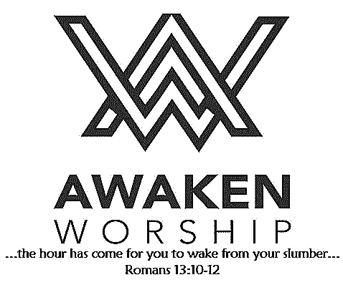

If you are visiting, thanks for being our guest today. Please fill out the guest info sheet in this bulletin. Take it to the

Welcome Desk after worship so we may introduce ourselves and give you a gift as our thanks to you for joining us today.

“Offer Gratitude” Community Thanksgiving Event: November 20, 6:30 p.m. at the St. Marys Union Hall, sponsored by the Ministerial Association, for the whole family. More details will be coming. Mark your calendar!

Helping Fellow Church People in

Their Time of Need By Using Our

God-given Talents and Gifts

Do you have skills, time and/or talents that you are willing to use to help others in need? Driving someone to a doctor appointment, providing lawn care/snow removal or making repairs are just a few types of assistance. Just let us know! A sign-up sheet is available in the fellowship hall. You may also send an email to [**waynestreethelpers@gmail.com**](mailto:waynestreethelpers@gmail.com). When the needs arise, you will be contacted by phone or email to ask for your assistance. If the request is something you can help with, you will then be connected with the person requesting services.

***If you have a need for assistance***,

please call the church office or

send an email to the Helpers

address (above). Someone

will contact you.

***More details are available***

***at the Information Desk.***

***You can also check our website:***

<https://waynestreetumc.org/wayne-street-helpers/>

Wayne Street

United Methodist Church

Love God. Love People. Change the World.

130 N. Wayne St., Saint Marys, OH

419-394-3615 [waynestreetoffice@gmail.com](mailto:waynestreetoffice@gmail.com)

[**http://www.waynestreetumc.org**](http://www.waynestreetumc.org)

**Pastor Tim Benjamin**

***Church Office Hours:***

Monday 1:30 – 4:30 pm

Tuesday thru Thursday 8:30 am – 12 / 1:30 – 4:30 pm

***Closed Friday***



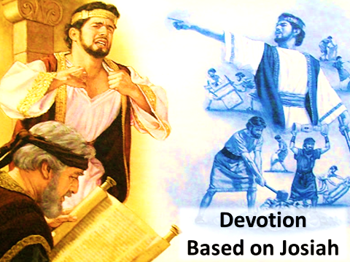

**October 13, 2019 10:45 a.m.**

**Pastor Tim Benjamin**

**(Worship Our Way!) *during AWAKEN***

*for children age 3 – 5th grade*

**Jessica Skinner, Director of Children’s Discipleship**

*Thanks for joining us as we:*

**GATHER**

**HIS Home in Haiti – Cheryl Kuck**

**CELEBRATE**

**PRAYER**

**LEARN**

**“Devotion Based On Josiah”**

2 Kings 22:1-13

**GIVE**

**SERVE**



**Jesus Heals**

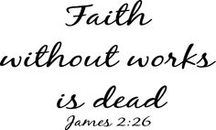

**Pastoral Care:** Call Pastor Tim at 419.394.3615 (choose ***option 2*** - pastoral care/ emergency). If he is unable to answer, he will return your call as soon as possible.

**Prayer Concerns:** Mary Musilek (mother of Dave Burkholder) (Cards may be sent to Mary at 100 Red Oak Dr., Cridersville, OH 45806.), children and staff at HIS Home in Haiti, family of **James “Jim” A. Ruwoldt (Mary Kay Brown’s brother)**

**Altar Flowers** are given by Jodi Hertenstein in memory of her brother.

***Volunteers are needed TODAY and next***

***Sunday, October 20*** *between worship*

*services* (from 9:30-10:45 a.m.) to assist with

assembling our Operation Christmas Child

shoeboxes.

We will also be placing encouraging words

and/or scripture inside each box.

Please join us in the fellowship hall;

your help will be appreciated.

**OCC shoeboxes** will be handed out on Sunday, October 27, and will be due back by November 17. A list of gift ideas to pack can be found on the Info Table, the Welcome Desk and in the church office. Watch for more information!

**Last Week:** Giving Toward Budget: $8,261

Attendance: 264

**October is Pastor Appreciation Month.** We will be collecting cards, gift cards and cash to present to Pastor Tim at the end of the month. Please mark your gift

“Pastor Appreciation” and drop in the offering plate or send to the church office. Questions? Call the church office.

***Pastor Tim has a revised bulletin, so he will not see this announcement!***

This Tuesday, October 15

Lunch at

*Leaving the church at 11 a.m.*, **600 Downtown Restaurant**,

*Sign up today at the Info Desk!* **Bellefontaine**

**Tuesday, October 15**

11:00 am – Ladies’ Lunch Bunch

6:30 pm – Celebrate Recovery

**Wednesday, October 16**

6:00 pm – COOL Worship for children age 3 - 5th grade

6:00 pm – Youth meeting

7:00 pm – Chancel Choir Practice

**Thursday, October 17**

9:00 am – Women of the Cloth sewing group

7:00 pm – AWAKEN Band practice

**Friday, October 18**

Church office closed

***Small Groups just started this week, so it’s not too***

***late to join* one of the many opportunities to take part**

**in a small group during our 40-day church-wide**

**spiritual growth effort to focus on community.**

**Hospitality Team: Sunday, October 20:**

***Kitchen Help*:** Brad and Jeannine Goodwin

***Clean-up:*** Goodwin / Keller

***Bakers:*** Sherri Lauth, Kelly Ginter, Dawn Knous,

Karen Evans, Becca Letteer

**Liturgist for Sunday, October 20:** Debbie Knox

**Liturgist for Sunday, October 27:** Trena Chiles

**MINISTERS: The Congregation**

**Pastor: Tim Benjamin** 419.394.3615, 740.262.7991

**Dirs., Student Discipleship: Phil / Leah Downs** 419.971.4321

**Dir., Children’s Discipleship: Jessica Skinner** 567.204.0312

**AWAKEN Worship Leader: Josh Barnes** 419.394.3615

**Office Manager: Diane Menchhofer** 419.394.3615

**Financial Controller: Angie Myers** 419-394-3615

**Choir Director & Organist: Darryl Smith** 419.953-2337

**Organist: Pam Wendel** 419.394.3615

**Nursery Coordinator: Kendra Syndram** 419.394.3615

**Custodian: Fred Hullinger** 419.394.3615

**Assistant Custodian:** **Gary Wibbeler** 419.394.3615

First Light Worship Celebration

October 13, 2019 8:30 a.m.

**\*Gathering Song** “Lord, Be Glorified”

**Welcome and Announcements**

**HIS Home in Haiti** Cheryl Kuck

**Prelude** “Praise to the Lord, the Almighty” Carter

**Responsive Reading:** Psalm 119:33-40 **# 842**

**Gloria Patri # 70**

**\*Opening Hymn** “Victory in Jesus” **# 370**

**Sharing the Journey**

**Pastoral Prayer**

**Offering / Offertory** “Hymn to Joy” Beethoven

**\*Doxology**

**\*Offertory Prayer**

**Anthem**  “Make His Praise Glorious” Larson

The Chancel Choir

**Scripture Reading:** 2 Kings 22:1-13

**Message** “Devotion Based on Josiah” Pastor Tim

**\*Hymn of Response** “Softly and Tenderly” **# 348, vs. 1,2,4**

**\*Sending Prayer**

**Postlude** “Hornpipe”

*(*) Please stand if you are able.*

**Today’s Organist:** Darryl Smith **Today’s Liturgist:** Rita Cassel

This Week at Wayne Street





**More information in the fellowship hall.**



**Our STAFF at Wayne Street UMC**