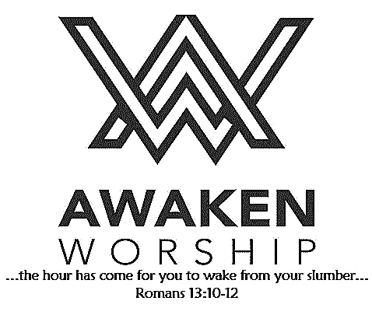

If you are visiting, thanks for being our guest today. Please fill out the guest info sheet in this bulletin. Take it to the

Welcome Desk after worship so we may introduce ourselves and give you a gift as our thanks to you for joining us today.

The annual Ladies’ Interfaith Breakfast, hosted by

Holy Rosary Altar Society, will be held Friday, October 4, at

9:30 a.m. All women are welcome to attend this event, which will be at Otterbein St. Marys. Please RSVP 419-394-6765 by Tuesday, October 1.

The annual WARM WINTER COAT DRIVE, sponsored by Agape Ministries, is being held through October 21. Donations of clean, gently used or new winter coats of all sizes may be brought to the church (barrels available in the fellowship hall).

Mark your calendars! The **Farmers’ Meal and Country Store**, presented by our United Methodist Women, is coming up on **November 6**!

Wednesday evenings at Wayne Street UMC are busy!

**COOL Worship** for children

age 3 through 5th grade begins at 6:00 p.m.

**Our youth** 6th-12th grades also meet at 6:00 p.m.

ALL kids are welcome to take

part in these activities.

Volunteers are also welcome!

See Jessica or Phil and Leah for

more information.

Wayne Street

United Methodist Church

Love God. Love People. Change the World.

130 N. Wayne St., Saint Marys, OH

419-394-3615 [waynestreetoffice@gmail.com](mailto:waynestreetoffice@gmail.com)

[**http://www.waynestreetumc.org**](http://www.waynestreetumc.org)

**Pastor Tim Benjamin**

***Church Office Hours:***

Monday 1:30 – 4:30 pm

Tuesday thru Thursday 8:30 am – 12 / 1:30 – 4:30 pm

***Closed Friday***

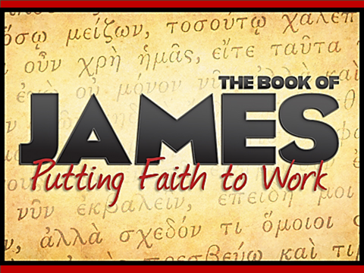

**September 29, 2019 10:45 a.m.**

**Pastor Tim Benjamin**

**(Worship Our Way!) *during AWAKEN***

*for children age 3 – 5th grade*

**Jessica Skinner, Director of Children’s Discipleship**

*Thanks for joining us as we:*

**GATHER**

**MISSION MOMENT:**

Operation Christmas Child - Condrys

**CELEBRATE**

**PRAYER**

**LEARN**

**“We Are Better Together”**

James 5:13-20

**GIVE**

**SERVE**







**Jesus Heals**

**Pastoral Care:** Call Pastor Tim at 419.394.3615 (choose ***option 2*** - pastoral care/ emergency). If he is unable to answer, he will return your call as soon as possible.

**Prayer Concerns:** Dale Barrett, family of Marjean Long

**Altar Flowers** are given by Murray and Barbara Fitzgerald in memory of their parents.

**$5 on the 5th Sunday**

***TODAY is a*** *“****5th Sunday.****”*

On each “5th Sunday” this year, we ask that everyone give to help children and families. These small individual gifts multiply and help change the lives of Ohio’s children and families who are looking for hope and healing.

***A basket is available at the back of***

***the sanctuary for your donations.***

**Please join one of the many opportunities**

**to take part in a small group during our**

**40-day church-wide spiritual growth**

**effort to focus on community.**

**As we deepen our faith in worship,**

**fellowship, discipleship, ministry and**

**missions... we love, grow and serve...**

**BETTER TOGETHER.**

**Tuesday, October 1**

6:30 pm – Celebrate Recovery

7:15 pm – Sonshine Circle at Angie Myers’ home

**Wednesday, October 2**

1:00 pm – Susanna Wesley Circle at Otterbein

6:00 pm – COOL Worship for children age 3 – 5th grade

6:00 pm – Youth meeting

7:00 pm – Chancel Choir Practice

**Thursday, October 3**

9:00 am – Women of the Cloth sewing group

7:00 pm – AWAKEN Band practice

**Friday, October 4**

Church office closed

**Hospitality Team: Sunday, October 6:**

***Kitchen Help*:** Dixie Durkee, Tiffany Davis

***Clean-up:*** Dicke / Lynch

***Bakers:*** Tiffany Davis, Kim Heitkamp, Irena Hollinger,

Ruth Huffman, Pam Swihart, Pam Wendel

**Liturgist for Sunday, October 6:** Dennis Chiles

**Liturgist for Sunday, October 13:** Rita Cassel

**Communion Teams for Sunday, October 6:**

**First Light:** Roberta Yingling **AWAKEN:** Joe & Kelly Ginter

**MINISTERS: The Congregation**

**Pastor: Tim Benjamin** 419.394.3615, 740.262.7991

**Dirs., Student Discipleship: Phil / Leah Downs** 419.971.4321

**Dir., Children’s Discipleship: Jessica Skinner** 567.204.0312

**AWAKEN Worship Leader: Josh Barnes** 419.394.3615

**Office Manager: Diane Menchhofer** 419.394.3615

**Financial Controller: Angie Myers** 419-394-3615

**Choir Director & Organist: Darryl Smith** 419.953-2337

**Organist: Pam Wendel** 419.394.3615

**Nursery Coordinator: Kendra Syndram** 419.394.3615

**Custodian: Fred Hullinger** 419.394.3615

**Assistant Custodian:** **Gary Wibbeler** 419.394.3615

**Last Week:** Giving Toward Budget: Available next Sunday

Attendance: 350

First Light Worship Celebration

September 29, 2019 8:30 a.m.

**\*Gathering Song** “Gentle Shepherd”

**Welcome and Announcements**

**Mission Moment:** Operation Christmas Child Condrys

**Prelude** “Festive Praise” Larson **Responsive Reading:** Psalm 8:1, 3-9 **# 743**

**Gloria Patri # 70**

**\*Opening Hymn** “Father, We Have Heard You Calling”

**Sharing the Journey**

**Pastoral Prayer**

**Offering/Offertory** “Here I Am, Lord” Wagner

**\*Doxology**

**\*Offertory Prayer**

**Anthem**  “O Lord, How Majestic Is Your Name!” Larson

The Chancel Choir

**Scripture Reading:** James 5:13-20

**Message** “We Are Better Together” Pastor Tim

**\*Hymn of Response # 549, vs. 1-4, 1**

“Where Charity and Love Prevail”

**\*Sending Prayer**

**Postlude “**The Church’s One Foundation” Wesley

*(*) Please stand if you are able.*

**Today’s Organist:** Darryl Smith **Today’s Liturgist:** Jack Miller

This Week at Wayne Street



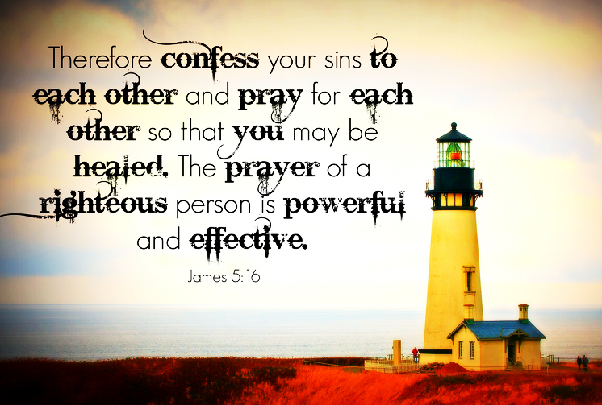

**More info in the fellowship hall!**

**Our STAFF at Wayne Street UMC**