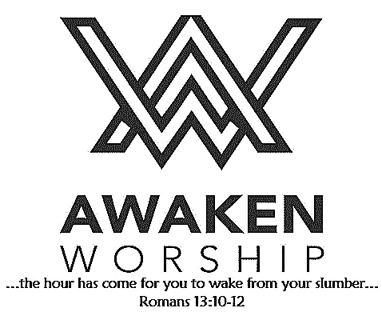

**Welcome!** If you are visiting, thanks for being our guest today. Please fill out the guest info sheet in this bulletin. Take it to the Welcome Desk after worship so we may introduce ourselves and give you a gift as our thanks to you for joining us today.

DO GOOD Restaurant and Ministry will hold a meeting, led by Carol Snyder, for **TUTORS** (those who want to share their knowledge with children) on Tuesday, September 17, at 6:30 p.m. at Karen Homan’s residence, 6712 Olding Rd., Maria Stein. Please contact Carol Snyder at 352-514-6585,[carolsny@gmail.com](mailto:carolsny@gmail.com) and let her know if you will be attending. Information packets and setting up schedules will be shared.  If you would like to be a part of this tutoring ministry, please come to the meeting.

**Do Good Restaurant and Ministry**

25 West Main Street, Osgood, Ohio 45351

419-582-GOOD (4663), [www.dogoodrm.com](http://www.dogoodrm.com/)

**Saturday, Sept. 21**, at

Wright State University Lake Campus

**Registration 9:00 a.m.**

**Ceremony / Walk 10:00 a.m.**

Please consider joining Pastor Tim or sponsoring him as he is committed to raising awareness and funds to support Alzheimer's care, support and research.

You can help in two ways: Walk with him, or make a donation on his fundraising page.

Visit the church website [**https://waynestreetumc.org/2019-walk-to-end-alzheimers-disease/**](https://waynestreetumc.org/2019-walk-to-end-alzheimers-disease/)for more details.

**Together, we can end Alzheimer's.**

**Church T-shirts**

We have a few t-shirts with our church logo left – **two extra-large** shirts and **one 2XL** shirt. $10 each, available in the church office. Call or stop in during office hours if you would like one!

is back in session! All kids age 3 through

grade 5 are welcome to join in the fun and

learning. Begins at 6:00 p.m. each

Wednesday.

***Parents must register their children each week.***

Wayne Street

United Methodist Church

Love God. Love People. Change the World.

130 N. Wayne St., Saint Marys, OH

419-394-3615 [waynestreetoffice@gmail.com](mailto:waynestreetoffice@gmail.com)

[**http://www.waynestreetumc.org**](http://www.waynestreetumc.org)

**Pastor Tim Benjamin**

***Church Office Hours:***

Monday 1:30 – 4:30 pm

Tuesday thru Thursday 8:30 am – 12 / 1:30 – 4:30 pm

***Closed Friday***

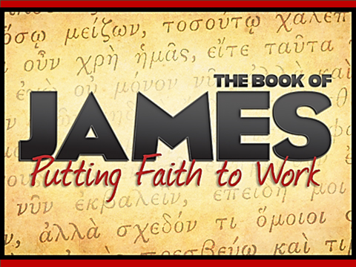

**September 15, 2019 10:45 a.m.**

**Pastor Tim Benjamin**

**(Worship Our Way!) *during AWAKEN***

*for children age 3 – 5th grade*

**Jessica Skinner, Director of Children’s Discipleship**

**Colleen Zunk, Assistant Director**

*Thanks for joining us as we:*

**GATHER**

**CELEBRATE**

**PRAYER**

**LEARN**

**“Evaluation”**

James 3:13-18

**GIVE**

**SERVE**



**Jesus Heals**



**Pastoral Care:** Call Pastor Tim at 419.394.3615 (choose ***option 2*** - pastoral care / emergency). If he is unable to answer, he will return your call as soon as possible.

**Prayer Concerns:** The family of Emerson Mack

**Altar Flowers** are given in honor of Mary Kay Brown’s birthday.

**Ladies’ Lunch Bunch – this Tues., Sept. 17**

All women are invited to enjoy lunch at Lulu’s in Wapak, followed by a trip to Amherst Greenhouse in Harrod. We will leave from the church at 11:00 a.m. and carpool to Wapak, with lunch scheduled for 11:30 a.m. Please sign up at the Info Desk today!

Landscaping help needed!

The church landscaped beds will be mulched on **Saturday, September 28, beginning at 8:00 a.m.** Volunteers are needed to load and spread the mulch. Wheelbarrows and scoop shovels will be provided, but if you can assist and have the tools, more would be helpful – garden rakes too. If you can help, contact Darryl Smith, Donovan Widney or Luke Yahl (or the church office – we will pass on your info). We will meet at the High Street parking lot at 8:00 a.m. and with enough help, should be done by 10:00 a.m.

**THANK YOU!**

**From the Congregational Connection Team:** Thanks to everyone who helped make our church picnic a success! Everyone appeared to enjoy themselves with a great time of fellowship, fun and good food.

Thank you all for the support, prayers, hugs and food for my family after my grandmother Jane Stewart’s passing. I was overwhelmed by the gifts and cards sent by so many, as well as the time taken from your busy schedules to support us during her viewing and funeral. The funeral meal was literally the best and Pastor Tim gave a meaningful service. Grandma would have been very pleased. I am eternally grateful for all of you and so proud that my family is part of a church where love is shown mainly by actions of its members.

With a humble and grateful heart,

Ellen Hunter and Family

**Tuesday, September 17**

11:00 am – Ladies’ Lunch Bunch

6:30 pm – Celebrate Recovery

**Wednesday, September 18**

6:00 pm – COOL Worship for children age 3 – 5th grade

6:00 pm – Youth meeting

7:00 pm – Chancel Choir Practice

**Thursday, September 19**

9:00 am – Women of the Cloth sewing group

7:00 pm – AWAKEN Band practice

**Friday, September 20**

Church office closed

***COMING IN OCTOBER:*** **Better Together!** Sermon Series and

Small Group Opportunities!

**Hospitality Team: Sunday, September 22:**

***Kitchen Help*:** Brad & Jeannine Goodwin

***Clean-up:*** Goodwin / Keller

***Bakers:*** Faith Hoagland, Valerie Cisco, Carol Burnett,

Carol Widney, Nicole Perin, Sandy Frey

**Liturgist for Sunday, September 22:** Debbie Knox

**Liturgist for Sunday, September 29:**

**MINISTERS: The Congregation**

**Pastor: Tim Benjamin** 419.394.3615, 740.262.7991

**Dirs., Student Discipleship: Phil / Leah Downs** 419.971.4321

**Dir., Children’s Discipleship: Jessica Skinner** 567.204.0312

**Assistant: Colleen Zunk** 419.394.3615

**Dir., Adult Discipleship: Tim Tuttle** 419.733.2774

**AWAKEN Worship Leader: Josh Barnes** 419.394.3615

**Office Manager: Diane Menchhofer** 419.394.3615

**Financial Controller: Angie Myers** 419-394-3615

**Choir Director & Organist: Darryl Smith** 419.953-2337

**Organist: Pam Wendel** 419.394.3615

**Nursery Coordinator: Kendra Syndram** 419.394.3615

**Custodian:** Fred Hullinger 419.394.3615

**Assistant Custodian:** Gary Wibbeler 419.394.3615

**Last Week:** Giving Toward Budget: $ 7,906

Attendance: 307

First Light

Worship Celebration

September 15, 2019 8:30 a.m.

**\*Gathering Song** “Just a Closer Walk with Thee”

**Welcome and Announcements**

**Prelude** “Be Thou My Vision” Larson

**\*Call to Worship**  **# 456**

**\*Gloria Patri # 70**

**\*Opening Hymn** “Praise the Source of Faith and Learning”

**Sharing the Journey**

**Pastoral Prayer**

**Offering/Offertory**  Wagner

“Make Me a Channel of Your Peace”

**\*Doxology**

**\*Offertory Prayer**

**Anthem** “If We Sing at All” Pethel

The Chancel Choir

**Scripture Reading:** James 3:13-18

**Message** “Evaluation” Pastor Tim

**\*Hymn of Response**  “Close to Thee” **# 407**

**\*Sending Prayer**

**Postlude** “Blessed Assurance” Knapp

*(*) Please stand if you are able.*

**Today’s Organist:** Darryl Smith **Today’s Liturgist:** Kraig Noble

This Week at Wayne Street



**Our STAFF at Wayne Street UMC**