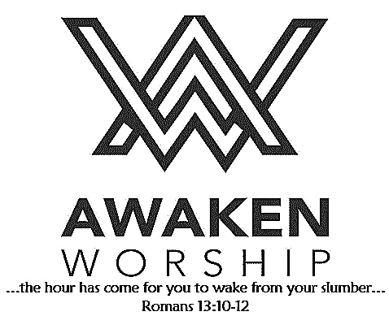

**WELCOME TO WAYNE STREET UMC!**

If you are visiting, thanks for being our guest today. Please fill out the guest info sheet in this bulletin. Take it to the Welcome Desk after worship so we may introduce ourselves and give you a gift as our thanks to you for joining us today.

**A 40-day church-wide spiritual growth campaign (sermon series and small groups’ topic)**

**to focus on community**

**Coming in October - Watch for more details!**

The church will be closed tomorrow, September 2,

for Labor Day.

**Ladies’ Lunch Bunch – Tues., Sept. 17**

All women are invited to enjoy lunch at Lulu’s in Wapak, followed by a trip to Amherst Greenhouse in Harrod. We will leave from the church at 11:00 a.m. and carpool to Wapak, with lunch scheduled for 11:30 a.m. Please sign up at the Info Desk, and indicate if you will be going to lunch and the greenhouse or just to lunch. Questions? Contact Patsy at 419-733-5789.

**Saturday, Sept. 21**, at

Wright State University Lake Campus

**Registration 9:00 a.m.**

**Ceremony / Walk 10:00 a.m.**

Please consider joining Pastor Tim or sponsoring him as he is committed to raising awareness and funds to support Alzheimer's care, support and research.

You can help in two ways: Walk with him, or make a donation on his fundraising page.

Visit the church website [**https://waynestreetumc.org/2019-walk-to-end-alzheimers-disease/**](https://waynestreetumc.org/2019-walk-to-end-alzheimers-disease/)for more details.

**Together, we can end Alzheimer's.**

Wayne Street

United Methodist Church

Love God. Love People. Change the World.

130 N. Wayne St., Saint Marys, OH

419-394-3615 [waynestreetoffice@gmail.com](mailto:waynestreetoffice@gmail.com)

[**http://www.waynestreetumc.org**](http://www.waynestreetumc.org)

**Pastor Tim Benjamin**

***Church Office Hours:***

Monday 1:30 – 4:30 pm

Tuesday thru Thursday 8:30 am – 12 / 1:30 – 4:30 pm

***Closed Friday***





**September 1, 2019 10:45 a.m.**

**Pastor Tim Benjamin**

**(Worship Our Way!) *during AWAKEN***

*for children age 3 – 5th grade*

**Jessica Skinner, Director of Children’s Discipleship**

**Colleen Zunk, Assistant Director**

*Thanks for joining us as we:*

**GATHER**

**CELEBRATE**

**PRAYER**

**LEARN**

**“We Are God’s Canvas”**

Matthew 7:13-29

**RECEIVE AND REMEMBER**

**SERVE**





**Jesus Heals**

**Pastoral Care:** Call Pastor Tim at 419.394.3615 (choose ***option 2*** - pastoral care/ emergency). If he is unable to answer, he will return your call as soon as possible.

**Prayer Concerns:** Family of Ralph Dennings,Colleen Zunk’s mother Pat, Colleen’s daughters

**Altar Flowers** are given in loving memory of Terry Moots by his family.

**All Women are welcome…**

* **Sonshine Circle’s** September meeting this Tuesday, September 3, will feature a carry-in dinner. It will be held at the home of Linda Burkholder at 6:00 p.m. For more information, contact the church office.
* The **Susanna Wesley Circle** will meet at 1:00 p.m. at Otterbein on Wednesday, September 4.

CHURCH PICNIC

**12 noon, next Sunday at the church**

**More details on your bulletin insert today!**

**Treats for Youth**

Our youth meets on Wednesday evenings and would appreciate baked (or purchased) treats. If you would like to provide, please sign up in the fellowship hall. The kids would welcome cookies, cupcakes, rice krispie treats – whatever you wish to share. Will need 3-4 dozen each week. The kids are not picky and there are no allergies to worry about. Thank you!

**From Bob and Myrna Wolfe:** Thank you all for prayers while Bob was going through chemo. The tumor has shrunk significantly! Praise God for answered prayers!

First Light

Worship Celebration

September 1, 2019 8:30 a.m.

**\*Gathering Song** “Through It All” **# 507**

“Turn Your Eyes Upon Jesus”  **# 349**

**Welcome and Announcements**

**Prelude** “He’s Got the Whole World in His Hands”Callahan

**Responsive Reading:** Psalm 81:1, 10-16

**Gloria Patri # 70**

**Opening Hymn** “How Firm a Foundation” **# 529**

**Sharing the Journey**

**Pastoral Prayer**

**Special Music** “Take My Life” Courtney

Darryl Smith, soloist

**Scripture Reading:** Matthew 7:13-29

**Message** “We Are God’s Canvas” Pastor Tim

**Holy Communion and Offering**

**\*Hymn of Response**  **# 444, vs. 1,2,5**

“O Young and Fearless Prophet”

**\*Sending Prayer**

**Postlude** “Finale” Cornell

*(*) Please stand if you are able.*

**Today’s Organist:** Darryl Smith **Today’s Liturgist:** Candy Dicke

**Monday, September 2**

Church closed for Labor Day

**Tuesday, September 3**

6:00 pm – Sonshine Circle Carry-in Dinner

6:30 pm – Celebrate Recovery

**Wednesday, September 4**

1:00 pm – Susanna Wesley Circle at Otterbein

6:00 pm – COOL Worship for children age 3 - 5th grade

6:00 pm – Youth meeting

7:00 pm – Chancel Choir Practice

**Thursday, September 5**

9:00 am – Women of the Cloth sewing group

7:00 pm – AWAKEN Band practice

**Friday, September 6**

Church office closed

**Hospitality Team: Sunday, September 8:**

***Kitchen Help*:** Tiffany Davis, Dixie Durkee

***Clean-up:*** Dicke / Lynch

***Bakers:*** Dixie Durkee, Ellen Adams, Kris Jacobs,

Christi Yahl, Linda Freewalt, Becky Jacobs

**Liturgist for Sunday, September 8:** Trena Chiles

**Liturgist for Sunday, September 15:** Kraig Noble

**MINISTERS: The Congregation**

**Pastor: Tim Benjamin** 419.394.3615, 740.262.7991

**Dirs., Student Discipleship: Phil / Leah Downs** 419.971.4321

**Dir., Children’s Discipleship: Jessica Skinner** 567.204.0312

**Assistant: Colleen Zunk** 419.394.3615

**Dir., Adult Discipleship: Tim Tuttle** 419.733.2774

**AWAKEN Worship Leader: Josh Barnes** 419.394.3615

**Office Manager: Diane Menchhofer** 419.394.3615

**Financial Controller: Angie Myers** 419-394-3615

**Choir Director & Organist: Darryl Smith** 419.953-2337

**Organist: Pam Wendel** 419.394.3615

**Nursery Coordinator: Kendra Syndram** 419.394.3615

**Custodian:** Fred Hullinger 419.394.3615

**Assistant Custodian:** Gary Wibbeler 419.394.3615

**Last Week:** Giving Toward Budget: $10,884

Attendance: 332

This Week at Wayne Street

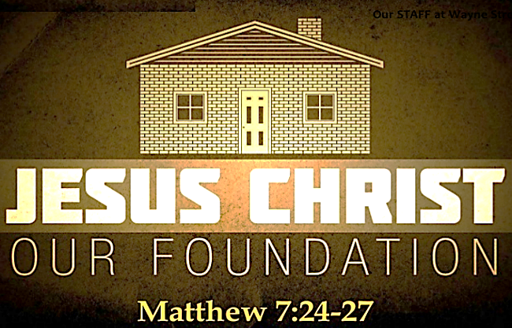

**Our STAFF at Wayne Street UMC**